Submitted To: Ma’am Sawera Naz 14 February 2026
Submitted By: Abdullah Iqbal
Sr. No: 71
Course: PF-Lab
Assignment: Task 2 (Lab Task using CLI)

Step-1: CREATE FOLDERS
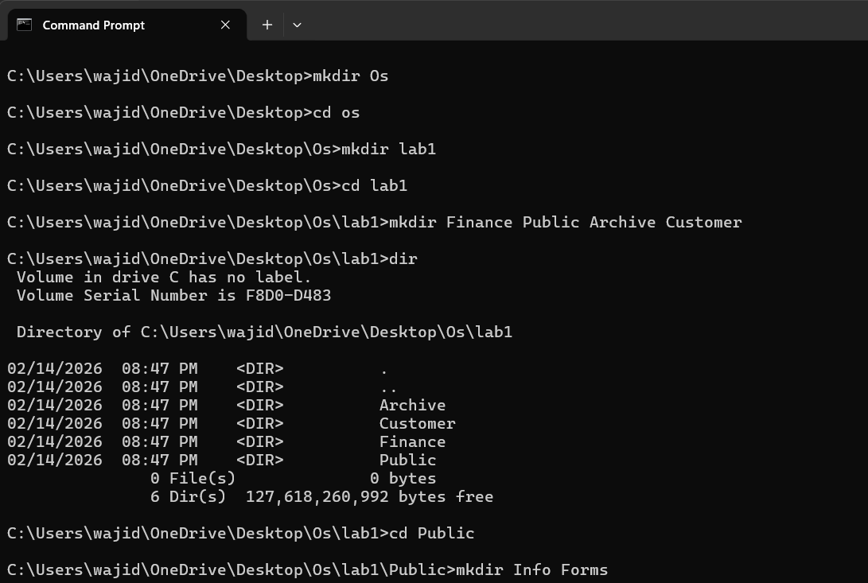

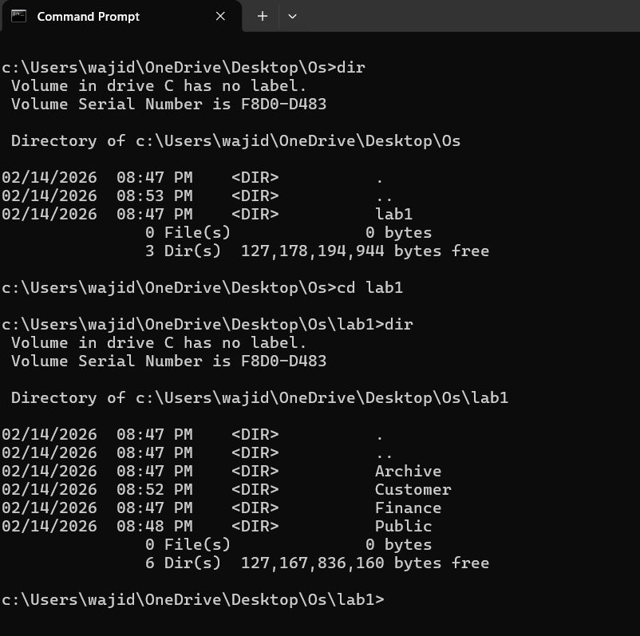
Step-2: Customer Files moved to Customer Directory
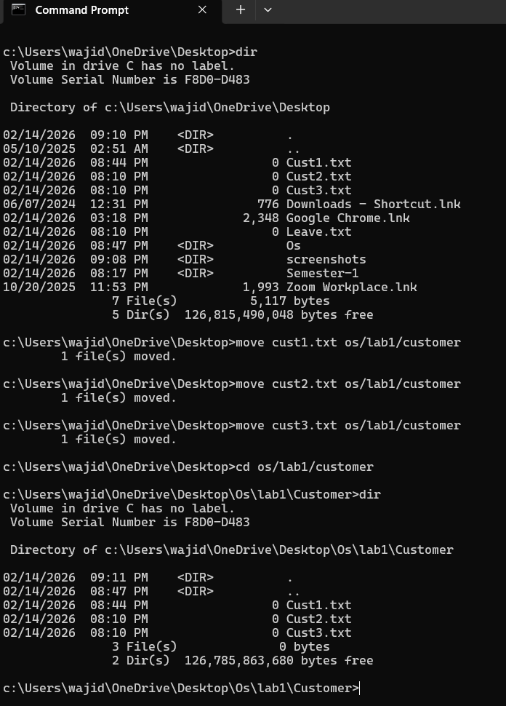

Step-3: Copy Customer Files to Archive Directory
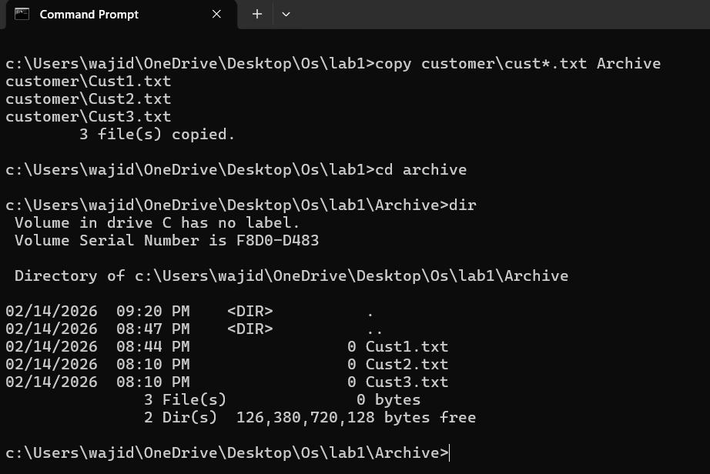
Step-4: Move the File to Archive directory
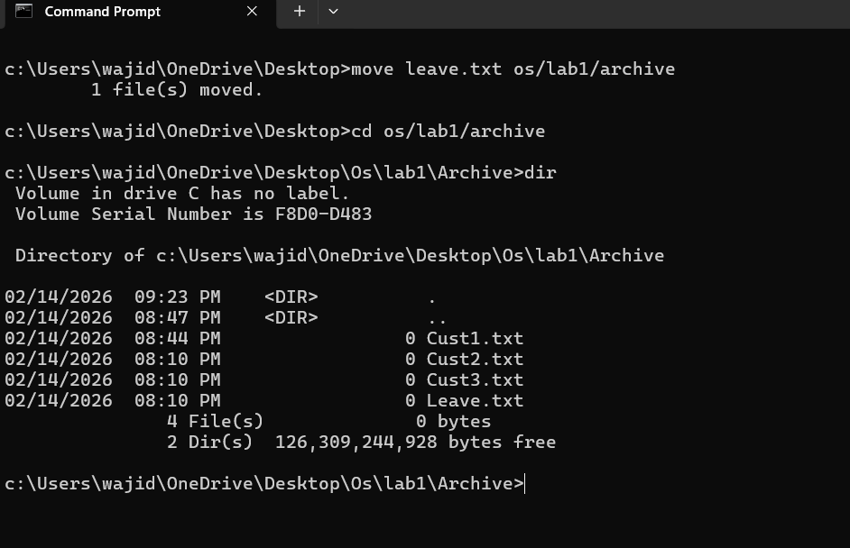

Rename:
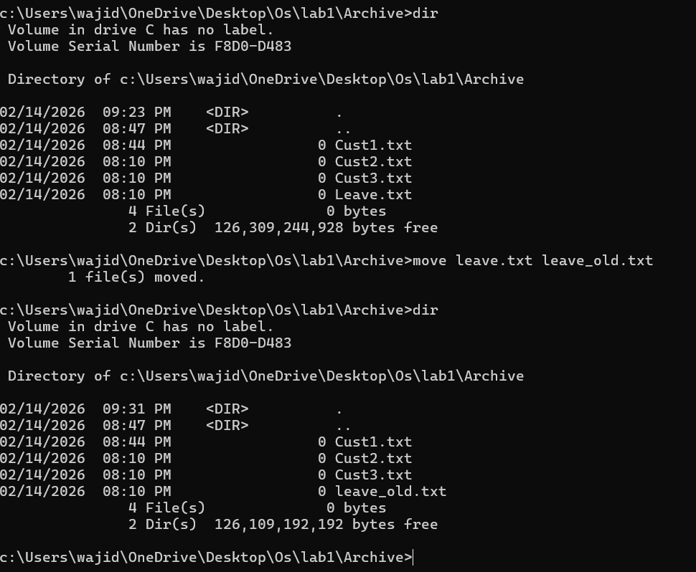
Step-5: Leave old.txt to the Forms Directory
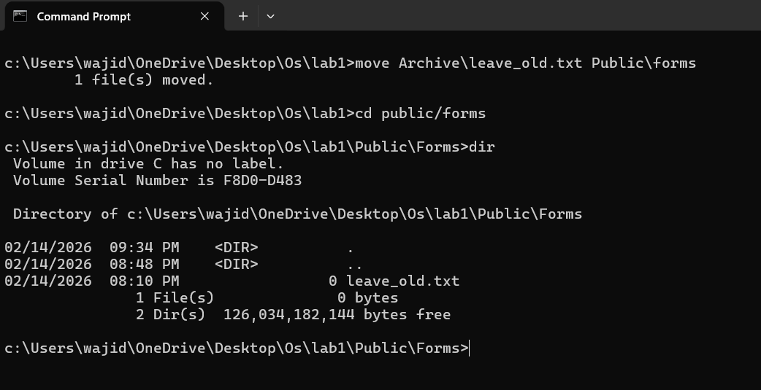

Step-6: Change to the Customer Directory
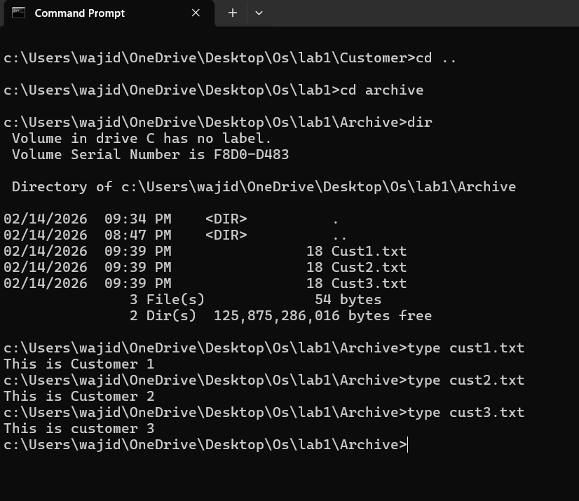
Step-7: Change to the Archive Directory
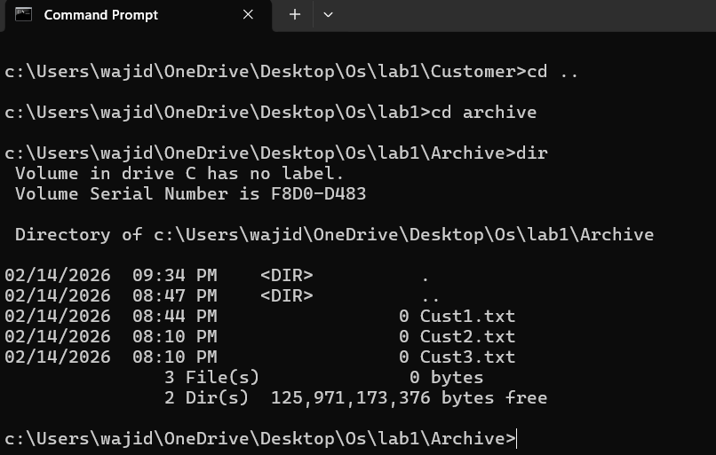

Step-8: Delete Customer Files
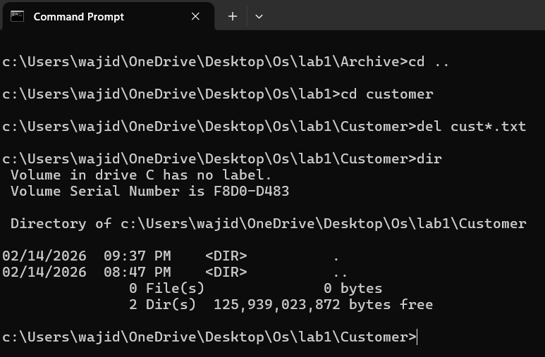
Step-9: Display the Contents

Step-10: Clear
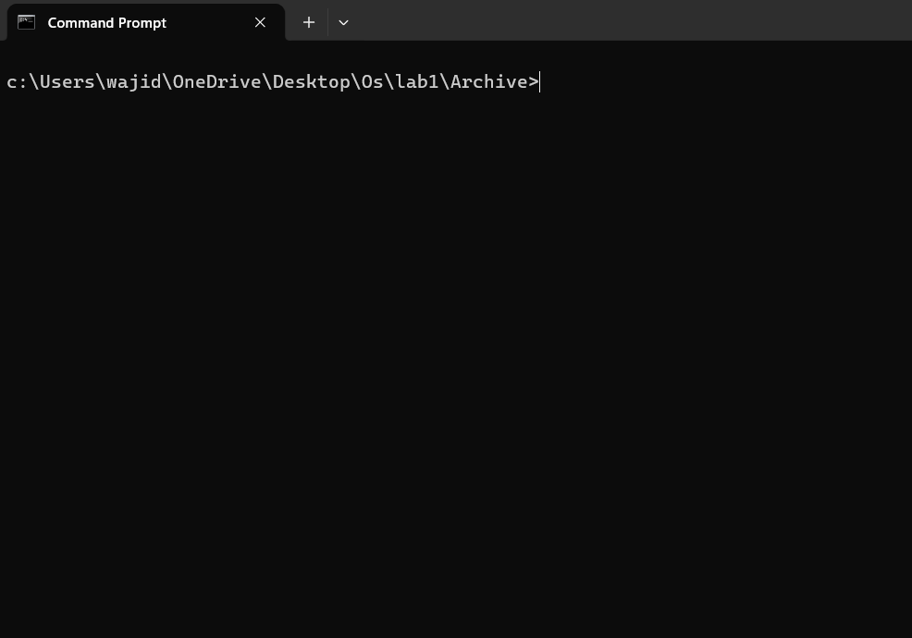
Step-11: Exit
